Chapter No :6

User Guide

* 1. **Patient**

**Sign Up**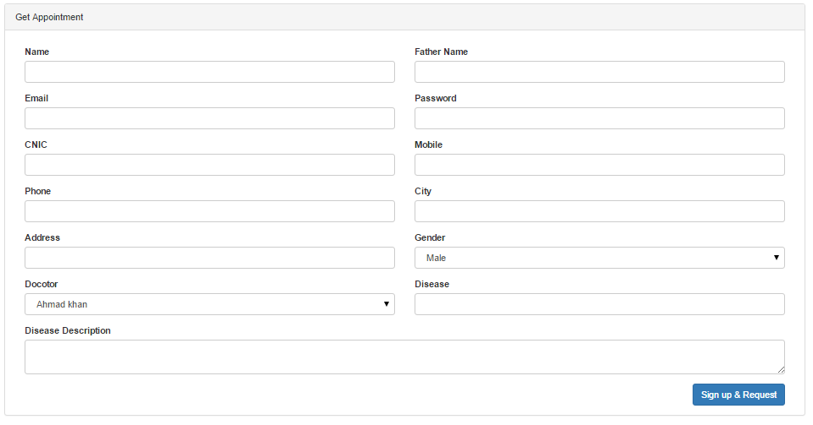

**Log in**

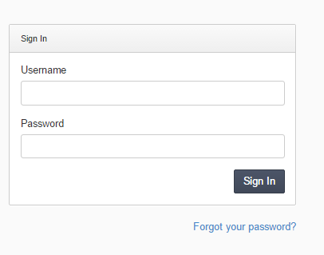

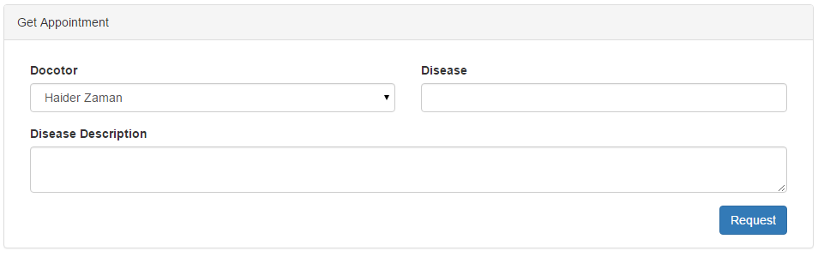Request Appointment

* 1. **Doctor**

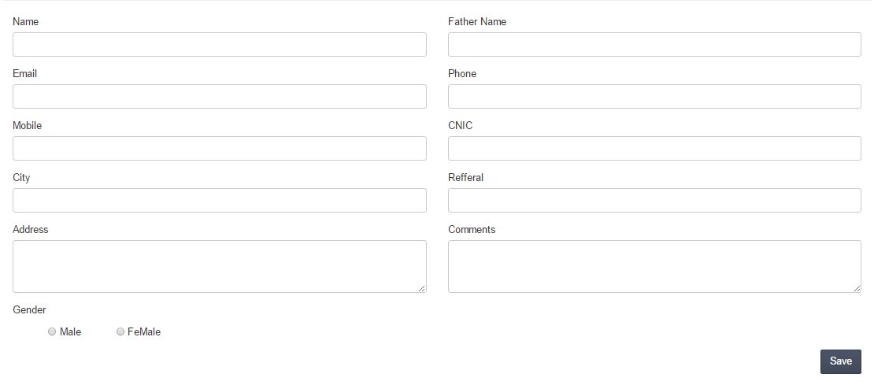Add patient

* 1. **Admin**
     1. **System Management**

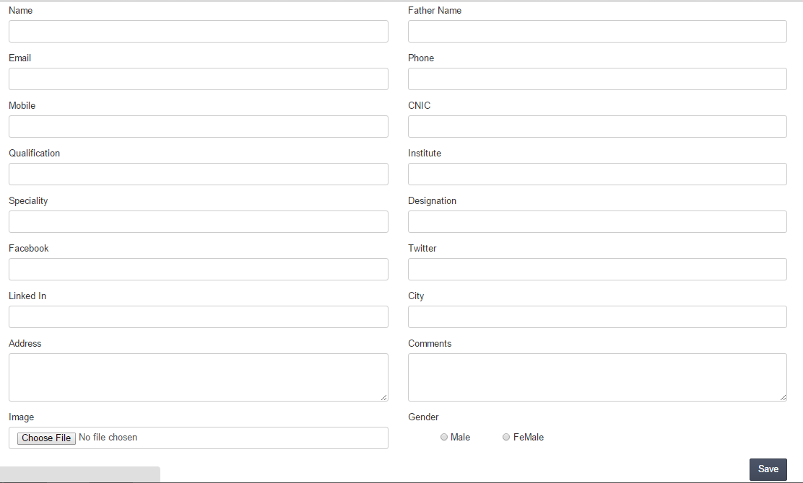Add Doctor

* + 1. **Website Management**

Add services

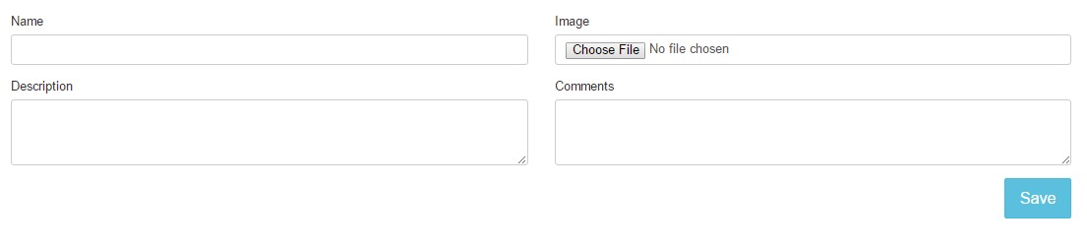

Add departments



Add diseases



Services

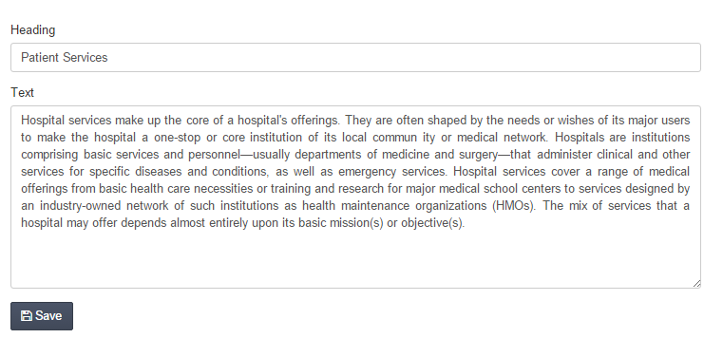

Departments

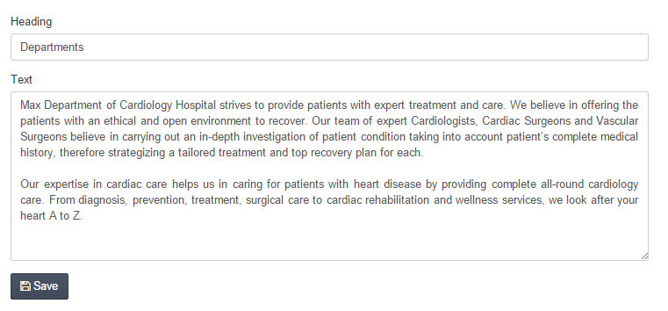

Diseases

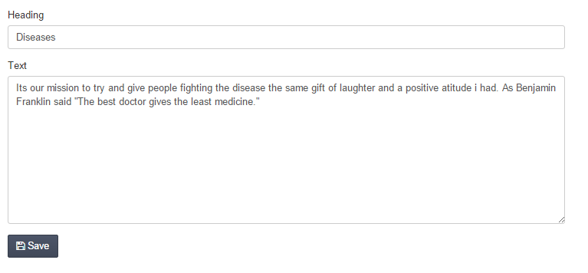

Contact us

